3.1.2 Modern Materials
- Be able to recognise a range of modern materials
- Know what Kevlar, Precious Metal Clay, High Density Modelling Foam and Polymorph are.
- Explain how modern materials can be used to
alter functionality

What are modern materials?
_________________________________________________________________________________________________________________________________________________________________________________________________________________________________

Name | Features | Uses
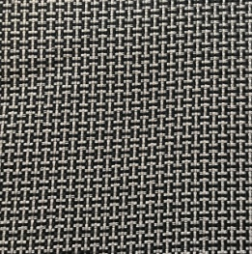
Kevlar
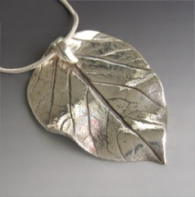
Precious Metal Clay (PMC)
High Density Modelling Foam
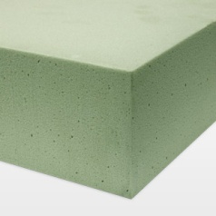
Polymorph
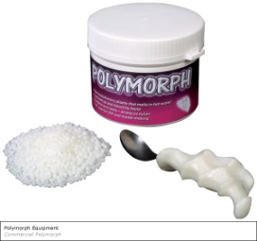

EXAM QUESTIONS
1. Why is Kevlar suitable for the sport of Fencing?
_________________________________________________________________________________________________________________________________________________________________________________________________________________________________
_________________________________________________________________________________________________________________________________________________________________________________________________________________________________
_________________________________________________________________________________________________________________________________________________________________________________________________________________________________
______________________________________________________________________________________________________________________________________________(6 Marks)

2. What affect has precious metal clay had on small businesses?
_________________________________________________________________________________________________________________________________________________________________________________________________________________________________
_________________________________________________________________________________________________________________________________________________________________________________________________________________________________
_________________________________________________________________________________________________________________________________________________________________________________________________________________________________
_________________________________________________________________________________________________________________________________________________________________________________________________________________________________
_________________________________________________________________________________________________________________________________________________________________________________________________________________________(6 marks)

3. Why is high density modelling foam suited to CNC Routering?
_________________________________________________________________________________________________________________________________________________________________________________________________________________________________
_________________________________________________________________________________________________________________________________________________________________________________________________________________________________
_________________________________________________________________________________________________________________________________________________________________________________________________________________________________
_________________________________________________________________________________________________________________________________________________________________________________________________________________________(4 marks)
5. Evaluate the impact of polymorph in the development of products.

_________________________________________________________________________________________________________________________________________________________________________________________________________________________________
_________________________________________________________________________________________________________________________________________________________________________________________________________________________________
_________________________________________________________________________________________________________________________________________________________________________________________________________________________________
_________________________________________________________________________________________________________________________________________________________________________________________________________________________________
_________________________________________________________________________________________________________________________________________________________________________________________________________________________(6 marks)

6. How have modern materials made an impact on product design over the last 10 years?
_________________________________________________________________________________________________________________________________________________________________________________________________________________________________
_________________________________________________________________________________________________________________________________________________________________________________________________________________________________
_________________________________________________________________________________________________________________________________________________________________________________________________________________________________
_________________________________________________________________________________________________________________________________________________________________________________________________________________________(6 marks)

